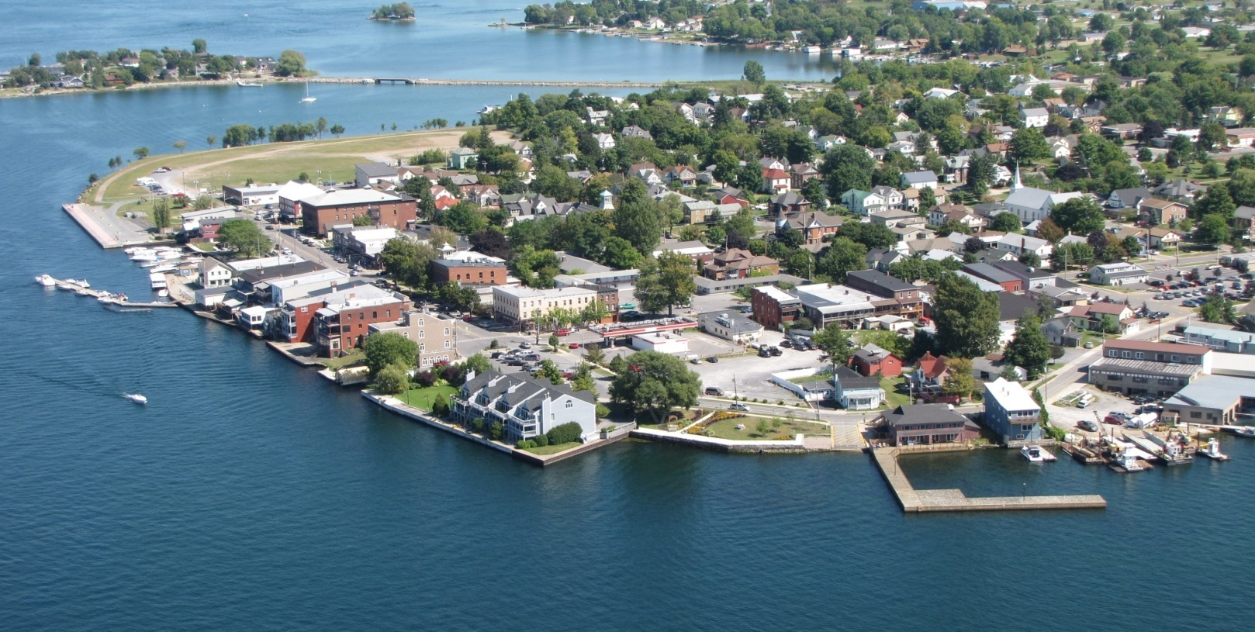
Clayton Local Development Corporation
Annual Report 2010

CLDC Mission Statement:

The mission of the not-for-profit Clayton Local Development Corporation (CLDC) is to improve the quality of life in the Village and Town of Clayton, New York, by stimulating economic development activities, encouraging business investments, retaining and increasing employment opportunities, attracting new businesses, encouraging the expansion and growth of existing businesses, and increasing the tax base. The CLDC is committed to working openly and cooperatively with public and private entities and funding sources and pledges to keep the community both informed and involved.

CLDC Board Members 2010

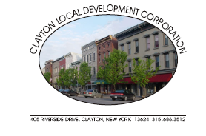
Officers

Chairman
Larry Aubertine, Vice-Chairman of Clayton Joint Planning Board, Ex-Officio Member

Vice-Chairman
Roland Baril, Chairman of the Clayton Joint Planning Board, Ex-Officio Member

Treasurer
Justin Taylor, Supervisor of the Town of Clayton, Ex-Officio Member

Secretary
Dr. Jon Slattery, retired Superintendent of Schools for Thousand Islands Central School District, Community Member

Assistant Secretary
Christopher Bogenschutz, President of the Clayton Chamber of Commerce, Ex-Officio Member

Ex-Officio Members

Norma Zimmer, Village of Clayton Mayor
Michael Docteur, Jefferson County Legislature, District #1
Joseph Menard, Superintendent of Schools, Thousand Islands School District

Community Members

John Kehoe, retired Air Force Colonel
Cary Brick, Chairman Clayton Heritage Alliance; Retired Chief of Staff, US House of Representatives (NY 23)
Kathy LaClair, Town of Clayton Clerk
Walt Christensen, local business owner
Rebecca Hopfinger, Executive Director of the Thousand Islands Art Center
Lori Durant, local business owner
Michael Geiss, retired NYS Parks; President of TI School District Board
2010 Highlights Annual Report 2010

Frink Property

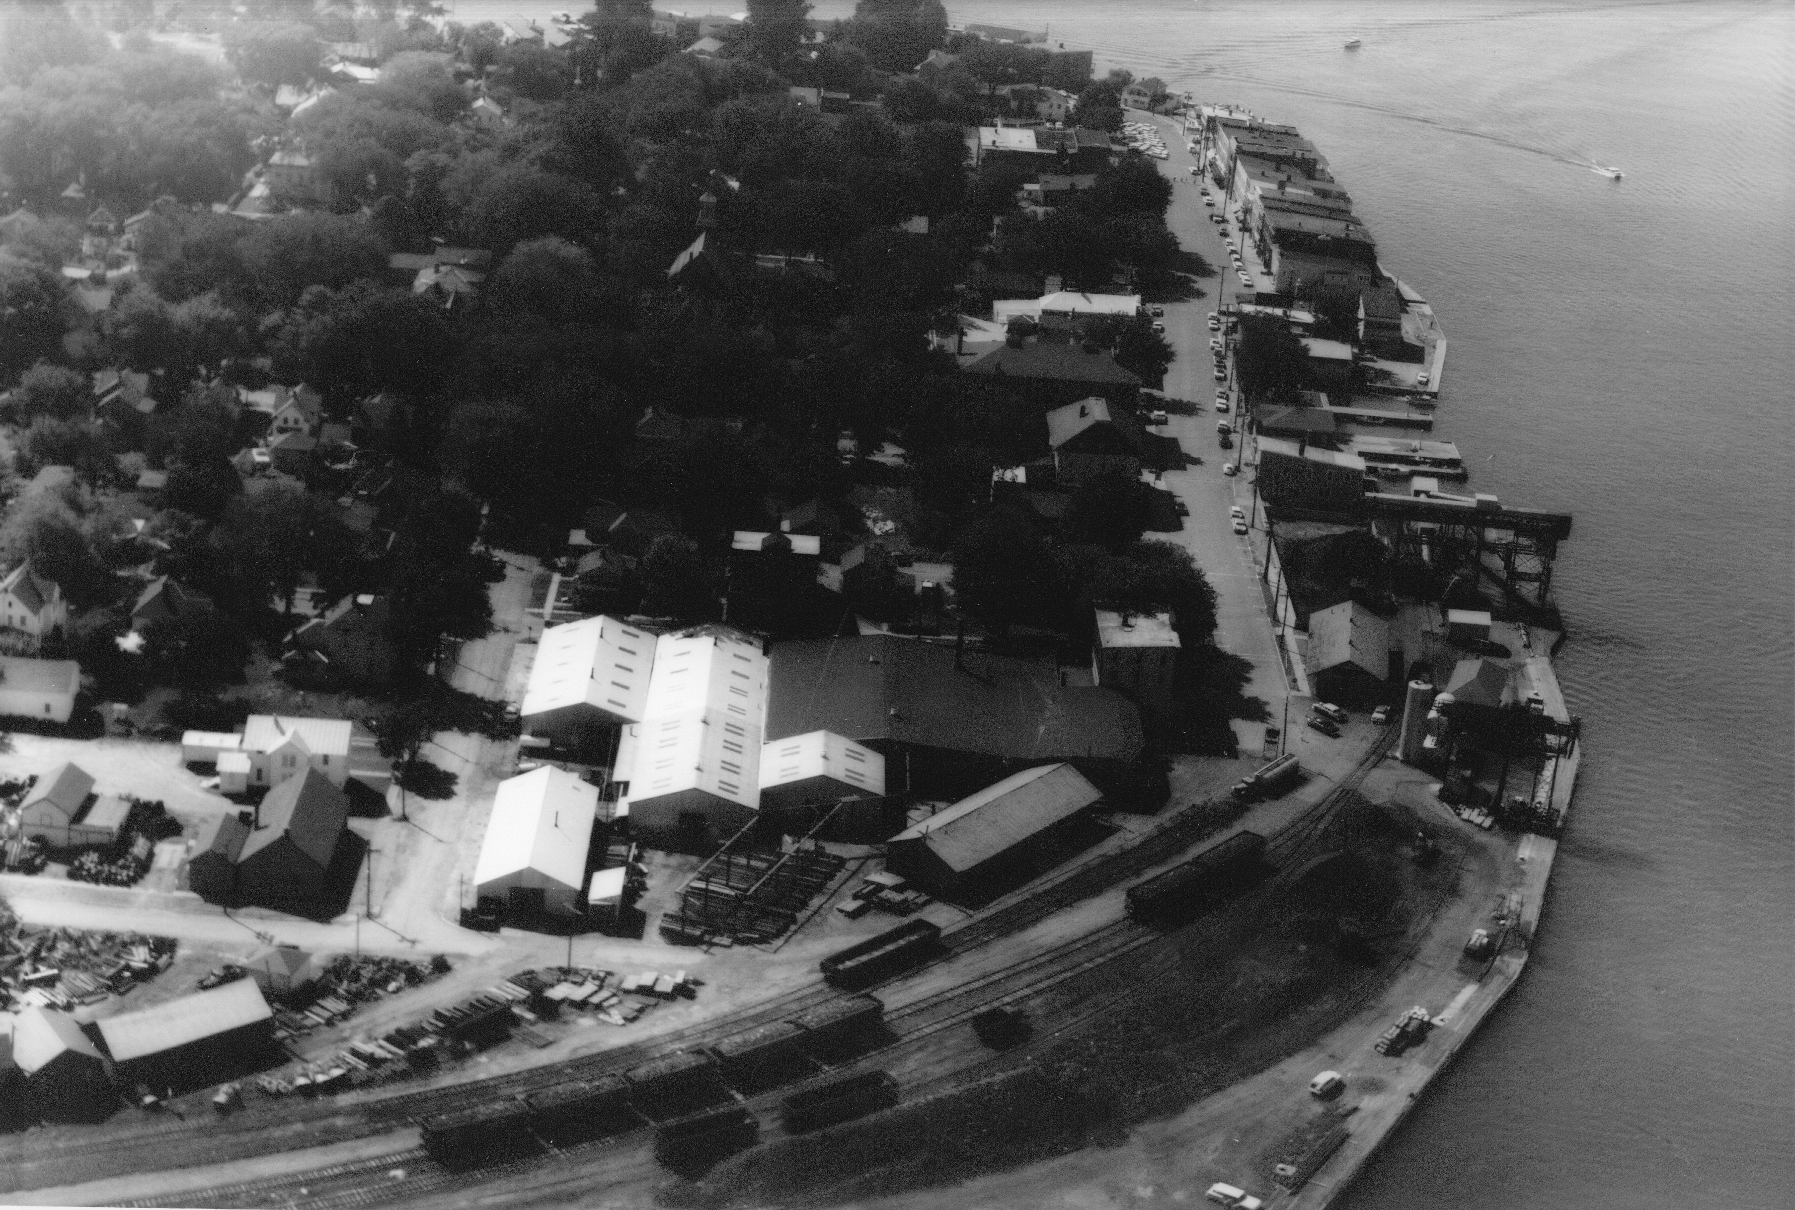
The CLDC in partnership with Town of Clayton completed the lengthy process of remediating the contaminated Frink Property. With the final contamination removed in 2008, the property received a Certificate of Completion for the remediation of the site in February 2010 from the NY State DEC. This important milestone is essential to future development the property.

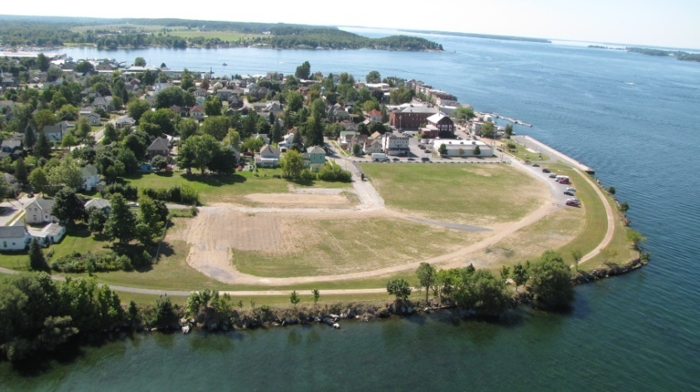
In June 2010, the municipal partners received responses to a Request for Proposals from prequalified developers interested in the Frink site. The responses were used to select a final developer to continue discussions. The selected developer, Krog Corporation is a development company based out of Orchard Park, NY. Krog maintains controlling interest in development properties of nearly 2 million square feet throughout Western NY, Central NY, the Finger Lakes Region and the Southern Tier. Their portfolio includes office buildings, medical facilities, manufacturing plants, educational buildings, housing and hospitality facilities.

The CLDC and Town of Clayton are continuing discussions with the Krog Corporation to create a future vision for the property. The goal is to have future development that will contribute towards economically revitalize the area, while maintaining the historic integrity of the community.
Boating Infrastructure Grant Program

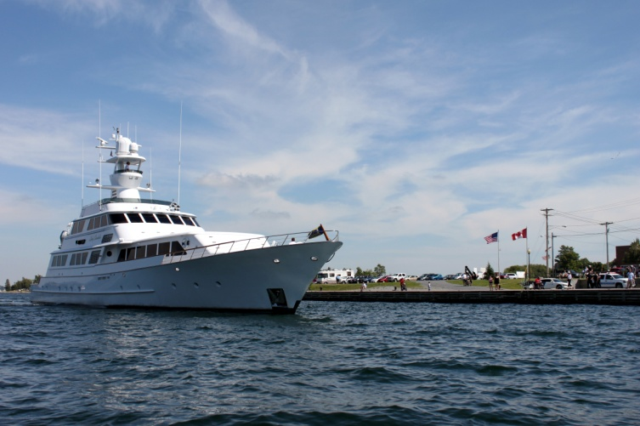
In April 2010, the CLDC, in partnership with the Town and Village of Clayton, received $1.1 million in funding from the U.S. Fish & Wildlife. The US Fish & Wildlife funds the Boating Infrastructure Grant Program through excise taxes on boating & fishing equipment and boating fuel. The BIG Program mandates that the funding be put back into the boating community by constructing facilities that benefit transient boaters. Transient boaters are defined as visitors staying in Clayton for 1 to 10 days with boats more than 26’ in length.

Clayton’s planned project includes building a docking facility for transient boats located off the north east corner of the Frink Property. A master plan has not yet been completed for the project, but is expected to include a breakwater, docks and bathhouse.
Lady Sandals 2010

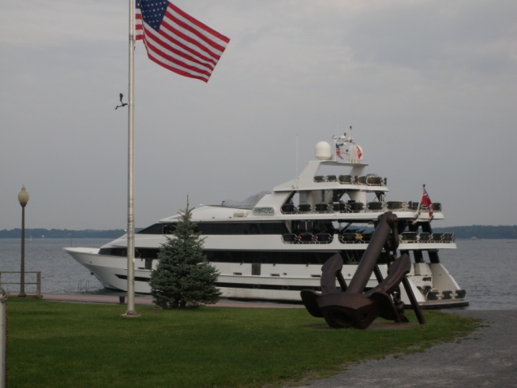
The location of the proposed transient docking facility is ideal to attract additional visitors to the Clayton area. Located off the Frink Property, visitors will be able to walk along the Riverwalk to enjoy the shops, restaurants, museums, parks and many other assets Clayton has to offer.

Mystere 2010

New York Main Street Program

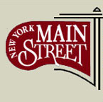
The CLDC received a $500,000 in funding from the New York Main Street Program. This grant program is designed to revitalize properties and improve streetscapes in local business districts. The goal of the program is to improve the commercial and residential properties located in older business district. There has been overwhelming interest in the funding program from local property owners with over $1 million requested for projects. Projects are expected to begin in Spring 2011 and continue through early 2012.

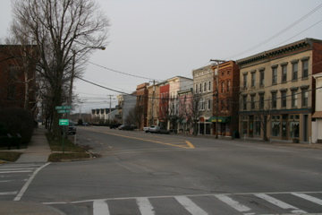
The Streetscape portion of the NYMS funds has been designated to replace the railings along Rotary Park and the Veteran’s Monument. These railings were originally installed over 50 years ago. The new railings are expected to be installed in Spring 2011.

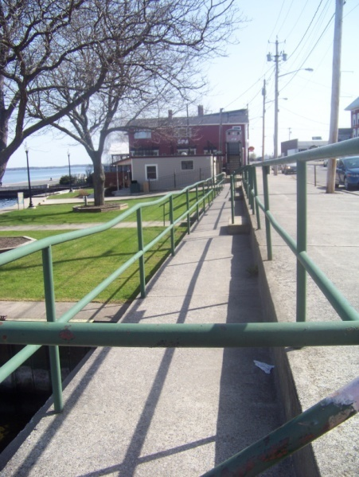
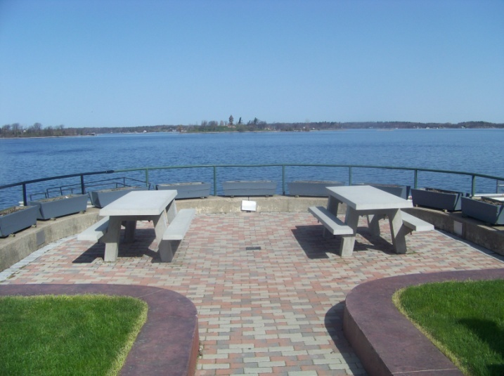
Riverside Drive

Rotary Park

Veteran’s Monument

Project Updates Annual Report 2010

Frink Park and Riverwalk Extension Project
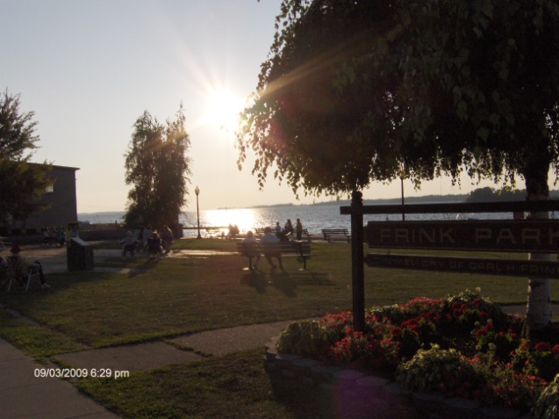
The CLDC in partnership with the Village of Clayton received funding from the NYS Department of State to make improvements to Frink Park and to extend the existing Riverwalk to the Veteran’s Monument. Aubertine & Currier and EDR have been hired as consultants on the project. Design work is expected to be complete by Summer of 2011.
Frink Park

Riverwalk- Frink Property

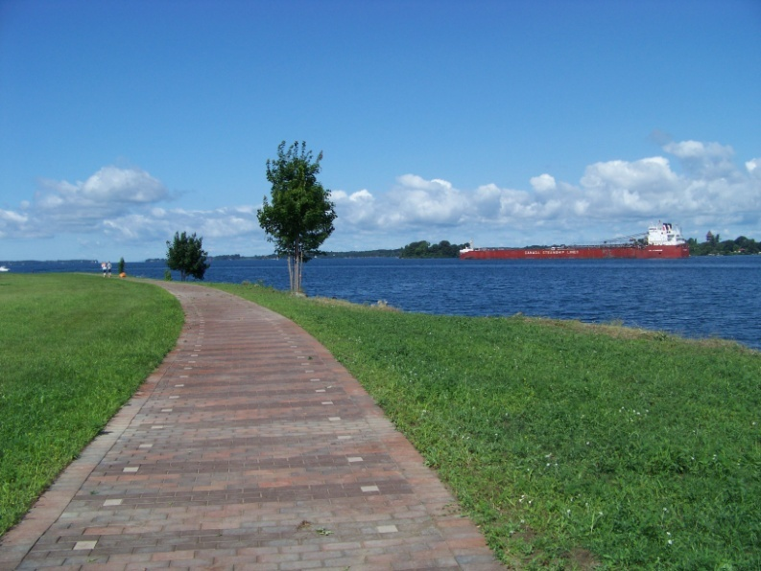
Amenities along the Riverwalk on the former Frink Property are planned to be designed and installed in 2011 and 2012. Overlooks, lighting, landscaping, seating and stairs and ramps to future docks are part of the overall plan to design and install amenities along the popular walkway.

Clayton Riverwalk

Joint Local Waterfront Revitalization Plan

The CLDC has worked with the Town and Village to complete the lengthy process of creating a Joint Local Waterfront Revitalization Plan (LWRP). This process was started several years ago with EDR consultants out of Syracuse. The bulk of the process has been completed, with the remainder, including a public presentation of the LWRP, planned to be completed in 2011.

Goals for 2011

- Continue towards full compliance with the PAAA of 2009
- Completion of the Joint Local Waterfront Revitalization Plan
- Progress towards a successful development on the Frink Property
- Development of a concept plan of the Riverwalk amenities and the future Transient Docking Facility
- Progress towards making Clayton a “walkable community”
- Creation and adoption of an Economic Development Plan

