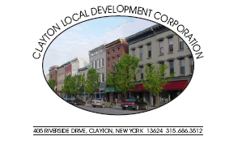

Clayton Local Development Corporation Board:
Larry Aubertine Chairman Norma Zimmer John Kehoe Bud Baril, Vice Chairman Cary Brick Kathy LaClair
John Slattery, Secretary Michael Docteur Mike Geiss
Chris Bogenschutz, Assistant Secretary Lori Durand Rebecca Hopfinger
Justin Taylor, Treasurer Walt Christensen Joseph Menard

Advisors: Rob Campany Paul Heckmann Bill Grater
Don Canfield Dennis Weller Jack Stopper
Gary DeYoung Matt Taylor CC: Clayton Town/Village Boards
Admin: Kristi Dippel

CLDC Meeting April 7th, 2011 @ the Opera House

CLDC MEETING AGENDA

Approval of March 3rd, 2011 Meeting Minutes

Chairman Larry Aubertine

Treasurer’s Report Justin Taylor

Administrative Report Kristi Dippel

Redevelopment Committee Paul Heckman

Clayton LWRP Committee Bill Grater/Bobby Cantwell

Frink Park/Riverwalk Committee Lori Durand

Old Business

New Business

2011 CLDC Meetings all beginning at 4:00 pm:
May 5**June 2 **July 7**August 4** September 1** October 6** November 3**December 2**
~All meetings are the first Thursday of the month and open to the public~

