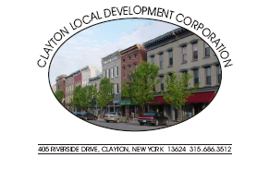

Clayton Local Development Corporation Board:
Larry Aubertine Chairman Norma Zimmer John Kehoe
Bud Baril, Vice Chairman Cary Brick Kathy LaClair
John Slattery, Secretary Michael Docteur Mike Geiss
Chris Bogenschutz, Assistant Secretary Lori Durand Rebecca Hopfinger
Justin Taylor, Treasurer Walt Christensen

Advisors: Rob Campany Paul Heckmann Bill Grater
Don Canfield Dennis Weller Jack Stopper
Gary DeYoung Matt Taylor CC: Clayton Town/Village Boards
Administration: Bob Cantwell, Executive Director, Kristi Dippel, Executive Assistant

CLDC Meeting: 4:00 PM Thursday, April 2, 2009 @ the Opera House.

CLDC MEETING AGENDA

Approval of March 5, 2009 Minutes

Chairman Larry Aubertine

Treasurer’s Report Justin Taylor

Executive Director Report Bob Cantwell

Frink Remediation Committee Bob Cantwell

Riverwalk-Frink Committee Lori Durand

Clayton LWRP Committee

Redevelopment Committee Paul Heckmann

Technology Committee Justin Taylor

Old Business

New Business

2009 CLDC Meetings all beginning at 4:00 pm:
5 *April 2 *May7 * June 4 *July 2*August 6 *September 3 *October 1 *November *December 3*
~All meetings are the first Thursday of the month and open to the public~

