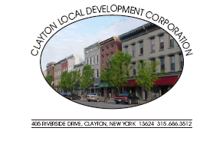

Clayton Local Development Corporation Board:
Larry Aubertine Chairman Norma Zimmer John Kehoe Bud Baril, Vice Chairman Cary Brick Kathy LaClair
John Slattery, Secretary Michael Docteur Mike Geiss
Chris Bogenschutz, Assistant Secretary Lori Durand Rebecca Hopfinger
Justin Taylor, Treasurer Walt Christensen Joseph Menard

Advisors: Rob Campany Paul Heckmann Bill Grater
Don Canfield Dennis Weller Jack Stopper
Gary DeYoung Matt Taylor CC: Clayton Town/Village Boards
Admin: Kristi Dippel

CLDC Meeting: 4:00 PM Thursday, October 1, 2009 @ the Opera House.

CLDC MEETING AGENDA

Approval of September 3, 2009 Minutes

Chairman Larry Aubertine

Treasurer’s Report Justin Taylor

Administrative Report Kristi Dippel

Shoreline Development Committee Lori Durand

Clayton LWRP Committee Bill Grater

Redevelopment Committee Paul Heckmann

Technology Justin Taylor

Old Business

New Business

2009 CLDC Meetings all beginning at 4:00 pm:
*October 1 *November 5 *December 3*
~All meetings are the first Thursday of the month and open to the public~

